Title (Cambria, bold, 14 pt, centered)
One empty line
J. Smith¹, J. Kowalski² (Cambria, bold, 12 pt, left aligned)
One empty line
¹UniversityA, address, e-mail (affiliation: Cambria, italic, 11 pt, left aligned)
²UniversityB, address, e-mail (affiliation: Cambria, italic, 11 pt, left aligned)
One empty line
General settings: 1-2 A4 page(s), Cambria, 11 pt, all margins 2.5 cm, space between lines: 1. First line of each paragraph should be indented 7,5 mm. The text should be justified.
One empty line
Figures pasted as gif, png, jpg images of good quality with resolution 300 dpi. Lines, axes and signs on the figures should be well visible – for your convenience, create .pdf file to check whether graphics are not corrupted in the process. Please, make sure you have permission to use all graphics. Final file size up to 2 Mb.
References should be placed in the text in square brackets [1]. Automatically numbered lists should not be used. List of references should be placed at the end of the text as separate section titled “References”.
One empty line
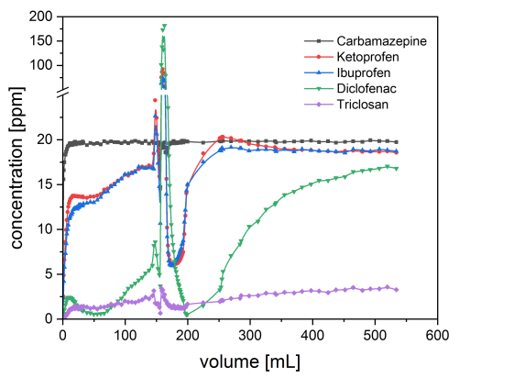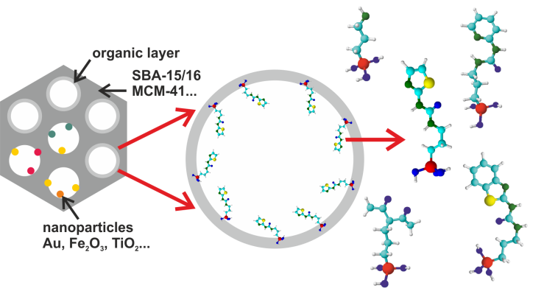
One empty line
Fig. 1. Figure caption. Centered, Cambria, 10 pt.
One empty line
Table 1. Table-related text should be left aligned, Cambria, 10 pt.
One empty line
References
[1] J. Brown, J. Catal. 72 (2005) 467 left aligned, Cambria, 10 pt.
[2] J. Kowalski, Nature 374 (1995) 42
[3] J. Smith, J. Kowalski, Micropor. Mesopor. Mater. 47 ( 2001) 157
One empty line
Acknowledgements: We thank National Science Foundation for….(left aligned, Cambria, 10 pt.)

Please, do not use: the section break or the page break,
and automatic numbering.

Please, label a file containing your abstract as:

Author1, Author2_poster(oral)

